STRATEGIC PARTNERSHIP AGREEMENT
between the European Union and its Member States, of the one part, and Canada, of the other part
THE EUROPEAN UNION, hereinafter referred to as ‘the Union’,
and
THE KINGDOM OF BELGIUM,
THE REPUBLIC OF BULGARIA,
THE CZECH REPUBLIC,
THE KINGDOM OF DENMARK,
THE FEDERAL REPUBLIC OF GERMANY,
THE REPUBLIC OF ESTONIA,
IRELAND,
THE HELLENIC REPUBLIC,
THE KINGDOM OF SPAIN,
THE FRENCH REPUBLIC,
THE REPUBLIC OF CROATIA,
THE ITALIAN REPUBLIC,
THE REPUBLIC OF CYPRUS,
THE REPUBLIC OF LATVIA,
THE REPUBLIC OF LITHUANIA,
THE GRAND DUCHY OF LUXEMBOURG,
HUNGARY,
THE REPUBLIC OF MALTA,
THE KINGDOM OF THE NETHERLANDS,
THE REPUBLIC OF AUSTRIA,
THE REPUBLIC OF POLAND,
THE PORTUGUESE REPUBLIC,
ROMANIA,
THE REPUBLIC OF SLOVENIA,
THE SLOVAK REPUBLIC,
THE REPUBLIC OF FINLAND,
THE KINGDOM OF SWEDEN,
THE UNITED KINGDOM OF GREAT BRITAIN AND NORTHERN IRELAND,
Contracting Parties to the Treaty on European Union and the Treaty on the Functioning of the European Union, hereinafter referred to as ‘the Member States’,
of the one part, and
CANADA,
of the other part,
hereinafter jointly referred to as ‘the Parties’,
INSPIRED BY the long-standing friendship forged between the people of Europe and Canada through their extensive historical, cultural, political and economic links,
NOTING the strides taken since the 1976 Framework Agreement for commercial and economic cooperation between the European Communities and Canada, the 1990 Declaration on Transatlantic Relations between the European Community and its Member States and Canada, the 1996 Joint Political Declaration on EU-Canada Relations and Joint EU-Canada Action Plan, the 2004 EU-Canada Partnership Agenda and the 2005 Agreement between the European Union and Canada establishing a framework for the participation of Canada in the European Union crisis management operations,
REAFFIRMING their strong attachment to democratic principles and human rights as laid down in the Universal Declaration of Human Rights,
SHARING the view that the proliferation of weapons of mass destruction poses a major threat to international security,
BUILDING on their long-standing tradition of cooperation in promoting international principles of peace and security and the rule of law,
REAFFIRMING their determination to combat terrorism and organised crime through bilateral and multilateral channels,
SHARING a commitment to reducing poverty, stimulating inclusive economic growth and assisting developing countries in their efforts towards political and economic reforms,
RECOGNISING their desire to promote sustainable development in its economic, social and environmental dimensions,
EXPRESSING pride in their extensive people-to-people contacts between their citizens and their commitment to the protection and promotion of the diversity of cultural expressions,
ACKNOWLEDGING the important role that effective multilateral organisations can play in advancing cooperation and achieving positive outcomes on global issues and challenges,
MINDFUL of their dynamic trade and investment relationship, which will be further enhanced through the effective implementation of a comprehensive economic and trade agreement,
RECALLING that the provisions of this Agreement that fall within the scope of Part Three, Title V of the Treaty on the Functioning of the European Union bind the United Kingdom and Ireland as separate Contracting Parties, and not as part of the European Union, unless the European Union together with the UK and/or Ireland have jointly notified Canada that the United Kingdom or Ireland is bound as part of the European Union in accordance with the Protocol No 21 on the position of the United Kingdom and Ireland in respect of the area of freedom, security and justice annexed to the Treaty on European Union and the Treaty on the Functioning of the European Union. If the United Kingdom and/or Ireland ceases to be bound as part of the European Union in accordance with Article 4a of the Protocol No 21, the European Union together with the UK and/or Ireland shall immediately inform Canada of any change in their position, in which case they shall remain bound by the provisions of the agreement in their own right. The same applies to Denmark in accordance with the Protocol annexed to those Treaties on the position of Denmark,
RECOGNISING the institutional changes in the European Union since the entry into force of the Treaty of Lisbon,
AFFIRMING their status as strategic partners and their determination to further enhance and elevate their relationship and their international cooperation on the basis of mutual respect and dialogue in order to advance their shared interests and values,
PERSUADED that such cooperation should take shape progressively and pragmatically, as their policies develop,
HAVE AGREED AS FOLLOWS:
TITLE I
BASIS FOR COOPERATION
Article 1
General principles
1. The Parties express their support for the shared principles set out in the Charter of the United Nations.
2. Mindful of their strategic relationship, the Parties shall endeavour to enhance coherence in developing their cooperation at the bilateral, regional and multilateral levels.
3. The Parties shall implement this Agreement based on shared values, the principles of dialogue, mutual respect, equal partnership, multilateralism, consensus and respect for international law.
TITLE II
HUMAN RIGHTS, FUNDAMENTAL FREEDOMS, DEMOCRACY AND THE RULE OF LAW
Article 2
Upholding and advancing democratic principles, human rights and fundamental freedoms
1. Respect for democratic principles, human rights and fundamental freedoms, as laid down in the Universal Declaration of Human Rights and existing international human rights treaties and other legally binding instruments to which the Union or the Member States and Canada are party, underpins the Parties' respective national and international policies and constitutes an essential element of this Agreement.
2. The Parties shall endeavour to cooperate and uphold these rights and principles in their own policies and shall encourage other states to adhere to those international human rights treaties and legally binding instruments and to implement their own human rights obligations.
3. The Parties are committed to advancing democracy, including free and fair electoral processes in line with international standards. Each Party shall inform the other of its respective election observation missions and invite the other to participate as appropriate.
4. The Parties recognise the importance of the rule of law for the protection of human rights and for the effective functioning of governance institutions in a democratic state. This includes the existence of an independent justice system, equality before the law, the right to a fair trial and individuals' access to effective legal redress.
TITLE III
INTERNATIONAL PEACE AND SECURITY AND EFFECTIVE MULTILATERALISM
Article 3
Weapons of mass destruction
1. The Parties consider that the proliferation of weapons of mass destruction (WMDs) and their means of delivery, both to state and non-state actors, represents one of the most serious threats to international stability and security.
2. The Parties therefore agree to cooperate and to contribute to preventing the proliferation of WMDs and their means of delivery through full compliance with and implementation of their obligations under international disarmament and non-proliferation agreements and UN Security Council Resolutions. In addition, the Parties shall continue to cooperate, as appropriate, in support of non-proliferation efforts through participation in the export control regimes to which both are party. The Parties agree that this provision constitutes an essential element of this Agreement.
3. The Parties furthermore agree to cooperate and to contribute to preventing the proliferation of WMDs and their means of delivery by:
(a) | as appropriate, taking steps to sign, ratify or accede to all relevant international disarmament and non-proliferation treaties and to fully implement all obligations under the treaties to which they are party and encourage other states to adhere to those treaties;

(b) | maintaining an effective system of national export controls, controlling the export and preventing the illicit brokering and transit of WMD-related goods, including a WMD end-use control on dual-use technologies and containing effective sanctions for breaches of export controls;

(c) | combating the proliferation of chemical, biological and toxin weapons. The Parties agree to collaborate in relevant fora to advance the prospects for universal adherence to international conventions, including the Chemical Weapons Convention (Convention on the Prohibition of the Development, Production, Stockpiling and Use of Chemical Weapons and on their Destruction) and the Biological and Toxin Weapons Convention (Convention on the Prohibition of the Development, Production and Stockpiling of Bacteriological (Biological) and Toxin Weapons and on their Destruction).
4. The Parties agree to establish a regular senior-level EU-Canada meeting to exchange views on ways of furthering cooperation on a range of non-proliferation and disarmament issues.
Article 4
Small arms and light weapons
1. The Parties recognise that the illicit manufacture, transfer and circulation of small arms and light weapons (SALWs), including their ammunition, and their excessive accumulation, poor management, inadequately secured stockpiles and uncontrolled spread continue to pose a serious threat to peace and international security.
2. The Parties agree to implement their respective commitments to deal with the illicit trade in SALWs, including their ammunition, in the framework of the relevant international instruments, including the UN Programme of Action to Prevent, Combat and Eradicate the Illicit Trade in SALWs in All Its Aspects as well as obligations deriving from UN Security Council Resolutions.
3. The Parties shall endeavour to take measures to deal with the illicit trade in SALWs and to cooperate and seek coordination, complementarity and synergy in their common efforts to assist other states in dealing with the illicit trade in SALWs and ammunition at global, regional and national levels, as appropriate.
Article 5
International Criminal Court
1. The Parties affirm that the most serious crimes of concern to the international community must not go unpunished and that their effective prosecution must be ensured through taking measures at the national level and through enhancing international cooperation, including with the International Criminal Court (ICC).
2. The Parties share a common commitment to promoting the universal ratification of, or accession to, the Rome Statute of the ICC, and to work towards its effective domestic implementation of the Statute amongst States Parties to the ICC.
Article 6
Cooperation in combating terrorism
1. The Parties recognise that the fight against terrorism is a shared priority and emphasise that the fight against terrorism shall be conducted with respect for the rule of law, international law, in particular the Charter of the United Nations and relevant United Nations Security Council Resolutions, human rights, international refugee law, humanitarian law and fundamental freedoms.
2. The Parties shall maintain high-level counter-terrorism consultations and ad hoc contacts with a view to promoting effective joint counter-terrorism operational efforts and collaborative mechanisms where possible. This shall include regular exchanges on terrorist listings, countering violent extremism strategies and approaches to emerging counter-terrorism issues.
3. The Parties share a common commitment to the promotion of a comprehensive international approach to combating terrorism under the leadership of the United Nations. The Parties shall endeavour in particular to cooperate in order to deepen the international consensus in this field to promote the full implementation of the UN Global Counterterrorism Strategy and the relevant UN Security Council resolutions, as appropriate.
4. The Parties shall continue to cooperate closely in the framework of the Global Counter-Terrorism Forum and its working groups.
5. The Parties shall be guided by the international recommendations established by the Financial Action Task Force to combat the financing of terrorism.
6. The Parties shall continue to work together as appropriate to enhance the counter-terrorism capacity of other states to prevent, detect and respond to terrorist activity.
Article 7
Cooperation in promoting international peace and stability
To advance their common interests in promoting international peace and security and effective multilateral institutions and policies, the Parties shall:
(a) | continue their efforts to further strengthen transatlantic security, taking into account the central role of the existing transatlantic security architecture between Europe and North America;

(b) | strengthen their joint efforts in support of crisis management and capacity-building, and further enhance their cooperation in this regard, including on EU operations and missions. The Parties shall endeavour to facilitate participation in these activities, including through early consultations and the sharing of planning information where it is deemed appropriate by the Parties.
Article 8
Cooperation in multilateral, regional and international fora and organisations
1. The Parties share a commitment to multilateralism and efforts to improve the effectiveness of regional and international fora and organisations such as the United Nations and its specialised organisations and agencies, the Organisation for Economic Co-operation and Development (OECD), the North Atlantic Treaty Organization (NATO), the Organization for Security and Co-operation in Europe (OSCE) and other multilateral fora.
2. The Parties shall maintain effective consultation mechanisms on the margins of multilateral fora. At the UN, in addition to their existing dialogues in the areas of human rights and democracy, the Parties shall establish permanent consultation mechanisms at the Human Rights Council, the General Assembly of the United Nations and the UN Offices in Vienna and others, as appropriate and agreed by the Parties.
3. The Parties shall also endeavour to consult on elections to seek effective representation in multilateral organisations.
TITLE IV
ECONOMIC AND SUSTAINABLE DEVELOPMENT
Article 9
Dialogue and global leadership on economic issues
Recognising that sustainable globalisation and greater prosperity can only be achieved through an open world economy, based on market principles, effective regulations and strong global institutions, the Parties shall endeavour to:
(a) | demonstrate leadership in promoting sound economic policies and prudent financial management both domestically and through their regional and international engagement;

(b) | hold a regular senior-level policy dialogue on macro-economic issues, including central bank representatives as appropriate, with the aim of cooperating on issues of mutual concern;

(c) | encourage, as appropriate, timely and effective dialogue and cooperation on global economic issues of common interest in multilateral organisations and fora in which the Parties participate, such as the OECD, the G-7, the G-20, the International Monetary Fund (IMF), the World Bank and the World Trade Organisation (WTO).
Article 10
Promoting free trade and enhancing investment
1. The Parties will cooperate in order to promote a sustainable increase and development of trade and investment between them to their mutual advantage, as provided for in a comprehensive economic and trade agreement.
2. The Parties shall endeavour to cooperate in order to further strengthen the WTO as the most effective framework for a strong, inclusive and rules-based global trading system.
3. The Parties shall continue to engage in customs cooperation.
Article 11
Cooperation on taxation
With a view to strengthening and developing their economic cooperation, the Parties adhere to and apply the principles of good governance in the tax area, i.e., transparency, exchange of information and avoidance of harmful tax practices in the frameworks of the OECD Forum on harmful tax practices and the Union Code of Conduct on business taxation, as applicable. The Parties shall endeavour to work together to promote and improve the implementation of these principles internationally.
Article 12
Sustainable development
1. The Parties reaffirm their commitment to meet the needs of today without compromising the needs of future generations. They recognise that, to be viable over the longer term, economic growth should respect the principles of sustainable development.
2. The Parties shall continue to promote the responsible and efficient use of resources and raise awareness of the economic and social costs of environmental damage and its associated impact on human well-being.
3. The Parties shall continue to encourage efforts to promote sustainable development through dialogue, the sharing of best practices, good governance and sound financial management.
4. The Parties share a common goal of reducing poverty and supporting inclusive economic development around the globe, and shall endeavour to work together whenever possible to achieve this aim.
5. For this purpose, the Parties shall establish a regular policy dialogue on development cooperation in order to improve policy coordination on common issues of interest and to improve the quality and effectiveness of their development cooperation, in line with internationally accepted principles on aid effectiveness. The Parties shall work together to strengthen accountability and transparency with a focus on improving development results, and shall recognise the importance of engaging a range of actors, including the private sector and civil society, in development cooperation.
6. The Parties recognise the importance of the energy sector to economic prosperity and international peace and stability. They agree on the need to improve and diversify energy supplies, promote innovation and increase energy efficiency in order to strengthen energy opportunity, energy security, and sustainable and affordable energy. The Parties shall maintain a high-level dialogue on energy and continue to collaborate through bilateral and multilateral means in order to support open and competitive markets, share best practices, promote science-based, transparent regulation, and discuss areas of cooperation on energy issues.
7. The Parties attach great importance to the protection and conservation of the environment and recognise the need for high standards of environmental protection in order to conserve the environment for future generations.
8. The Parties recognise the global threat of climate change and the need to take immediate and further action to cut emissions in order to stabilise greenhouse gas concentrations in the atmosphere at a level that would prevent dangerous anthropogenic interference with the climate system. In particular, they share a common ambition to find innovative solutions to mitigate and adapt to the effects of climate change. The Parties recognise the global nature of the challenge and shall continue to support international efforts towards a fair, effective, comprehensive and rules-based regime under the United Nations Framework Convention on Climate Change (UNFCCC) that applies to all Parties to the Convention, including working together on moving the Paris Agreement forward.
9. The Parties shall maintain high-level dialogues on the environment and on climate change with a view to sharing best practices and promoting effective and inclusive cooperation on climate change and other issues relating to environmental protection.
10. The Parties recognise the importance of dialogue and cooperation at bilateral or multilateral levels in the field of employment, social affairs and decent work, particularly in the context of globalisation and demographic changes. The Parties shall endeavour to promote cooperation and exchanges of information and experiences on employment and social matters. The Parties also confirm their attachment to respect, promote and realise internationally recognised labour standards to which they have committed, such as those referred to in the 1998 International Labour Organization (ILO) Declaration on Fundamental Principles and Rights at Work and its follow-up.
Article 13
Dialogue on other areas of mutual interest
Recognising their shared commitment to deepen and expand their longstanding engagement as well as acknowledging existing cooperation, the Parties shall endeavour, in appropriate bilateral and multilateral fora, to encourage expert dialogue and exchanges of best practices in policy areas of mutual interest. These include, but are not limited to, the areas of: agriculture, fisheries, international ocean and maritime policy, rural development, international transportation, employment, and circumpolar issues including science and technology. Where appropriate, this could also include exchanges on legislative, regulatory and administrative practices, as well as on decision-making processes.
Article 14
Citizens' well-being
1. Recognising the importance of expanding and deepening their dialogue and cooperation on a wide range of issues that affect the well-being of their citizens and the larger global community, the Parties shall encourage and facilitate dialogue, consultation and, where possible, cooperation on existing and emerging issues of mutual interest affecting citizens' well-being.
2. The Parties recognise the importance of consumer protection and shall encourage the exchange of information and best practice in this area.
3. The Parties encourage mutual cooperation and information exchange on global health issues and on preparedness and response to global public-health emergencies.
Article 15
Cooperation on knowledge, research, innovation and communication technology
1. Considering the importance of new knowledge to address global challenges, the Parties shall continue to encourage cooperation in the field of science, technology, research and innovation.
2. Recognising the importance of information and communication technologies as key elements of modern life and socio-economic development, the Parties shall endeavour to cooperate and exchange views on national, regional and international policies in this field as appropriate.
3. Recognising that the security and stability of the Internet in full respect of fundamental rights and freedoms is a global challenge, the Parties shall endeavour to cooperate at bilateral and multilateral levels through dialogue and exchange of expertise.
4. The Parties recognise that the use of space systems is increasingly important to meet their socio-economic, environment and international policy objectives. The Parties shall continue to further their cooperation in the development and use of space assets to support citizens, businesses and government organisations.
5. The Parties shall endeavour to continue their cooperation in the field of statistics, with a particular focus on actively promoting the sharing of best practices and policies.
Article 16
Promoting the diversity of cultural expressions, education and youth, and people-to-people contacts
1. The Parties take pride in the long-standing cultural, linguistic and traditional ties that have built bridges of understanding between them. Transatlantic ties exist at all levels of government and society and the impact of this relationship is significant across Canadian and European societies. The Parties shall endeavour to encourage these ties and to seek new ways to foster relationships through people-to-people contacts. The Parties shall endeavour to use exchanges through non-governmental organisations and think-tanks that bring together youth and other economic and social partners to expand and deepen these relations and enrich the flow of ideas for the solution of common challenges.
2. Recognising the extensive academic, educational, sport, culture, tourism and youth mobility relationships that have developed between them over the years, the Parties welcome and encourage continued collaboration in expanding these linkages, as appropriate.
3. The Parties shall endeavour to foster the diversity of cultural expressions, including through the promotion, as appropriate, of the principles and objectives of the 2005 UNESCO Convention on the Protection and Promotion of the Diversity of Cultural Expressions.
4. The Parties shall endeavour to encourage and facilitate exchanges, cooperation and dialogue between their cultural institutions and professionals in this sector as appropriate.
Article 17
Disaster resilience and emergency management
To minimise the impact of natural and man-made disasters and increase the resilience of society and infrastructure, the Parties affirm their common commitment to promote prevention, preparedness, response and recovery measures, including through cooperation as appropriate at the bilateral and multilateral level.
TITLE V
JUSTICE, FREEDOM AND SECURITY
Article 18
Judicial cooperation
1. As regards judicial cooperation in criminal matters, the Parties shall seek to enhance existing cooperation on mutual legal assistance and extradition based on relevant international agreements. The Parties shall also, within their powers and competences, seek to strengthen existing mechanisms and, as appropriate, consider the development of new mechanisms to facilitate international cooperation in this area. This would include, as appropriate, accession to, and implementation of, the relevant international instruments and closer cooperation with Eurojust.
2. The Parties shall develop, as appropriate, judicial cooperation in civil and commercial matters, to the extent of their respective competences, in particular, as regards the negotiation, ratification and implementation of multilateral conventions on civil judicial cooperation, including the Conventions of the Hague Conference on Private International Law in the field of international legal cooperation and litigation as well as the protection of children.
Article 19
Cooperation against illicit drugs
1. Within their respective powers and competences, the Parties shall cooperate to ensure a balanced and integrated approach on drug issues. The Parties shall focus their efforts to:
— | reinforce structures for combating illicit drugs;

— | reduce the supply, trafficking and the demand for illicit drugs;

— | address the health and social consequences of illicit drug abuse; and

— | maximise the effectiveness of structures aimed at reducing the diversion of chemical precursors used for the illicit production of narcotic drugs and psychotropic substances.
2. The Parties shall collaborate to attain these objectives, including, where possible, by coordinating their technical assistance programmes and by encouraging countries that have not already done so to ratify and implement existing international drug control conventions to which the Union or the Member States and Canada are party. The Parties shall base their actions on commonly accepted principles in line with the relevant international drug control conventions and respect the overarching goals of the 2009 UN Political Declaration and Plan of Action on International Cooperation Towards an Integrated and Balanced Strategy to Counter the World Drug Problem.
Article 20
Law enforcement cooperation and the fight against organised crime and corruption
1. The Parties share a commitment to cooperating in combating organised, economic and financial crime, corruption, counterfeiting, smuggling and illegal transactions through compliance with their mutual international obligations in this area, including as regards effective cooperation in the recovery of assets or funds derived from acts of corruption.
2. The Parties affirm their commitment to developing law enforcement cooperation, including through continuing cooperation with Europol.
3. In addition, the Parties shall endeavour to collaborate in international fora to promote, as appropriate, adherence to and the implementation of the UN Convention Against Transnational Organized Crime and its supplementing Protocols to which they are both party.
4. The Parties shall also endeavour to promote, as appropriate, the implementation of the UN Convention against Corruption, including through the operation of a strong review mechanism, taking account of the principles of transparency and participation of civil society.
Article 21
Money laundering and the financing of terrorism
1. The Parties recognise the need to cooperate on preventing the use of their financial systems to launder the proceeds of all criminal activity, including drug trafficking and corruption, and to combat the financing of terrorism. This cooperation extends to the forfeiture of assets or funds derived from criminal activity, within their respective legal frameworks and laws.
2. The Parties shall exchange relevant information, as appropriate within their respective legal frameworks and laws, and implement appropriate measures to combat money laundering and the financing of terrorism, guided by the recommendations of the Financial Action Task Force and standards adopted by other relevant international bodies active in this area.
Article 22
Cybercrime
1. The Parties recognise that cybercrime is a global problem requiring global responses. To that end, the Parties shall strengthen cooperation to prevent and combat cybercrime through the exchange of information and practical knowledge, in compliance with their respective legal frameworks and laws. The Parties shall endeavour to work together, where appropriate, to provide assistance and support to other states in the development of effective laws, policies and practices to prevent and combat cybercrime wherever it occurs.
2. The Parties shall, as appropriate within their respective legal frameworks and laws, exchange information in fields including the education and training of cybercrime investigators, the conduct of cybercrime investigations and digital forensics.
Article 23
Migration, asylum and border management
1. The Parties reaffirm their commitment to cooperating and exchanging views within the framework of their respective laws and regulations in the areas of migration (including legal migration, irregular migration, trafficking in human beings, migration and development), asylum, integration, visas and border management.
2. The Parties share the objective of visa-free travel between the Union and Canada for all of their respective citizens. The Parties shall work together and make every effort to achieve, as soon as possible, visa-free travel between their territories for all citizens with a valid passport.
3. The Parties agree to cooperate in order to prevent and control irregular migration. To this end:
(a) | Canada shall readmit any of its citizens illegally present on the territory of a Member State, on request by the latter and, unless otherwise provided by a specific agreement, without further formalities;

(b) | Each Member State shall readmit any of its citizens illegally present on the territory of Canada, upon request by the latter and, unless otherwise provided by a specific agreement, without further formalities;

(c) | The Member States and Canada shall provide their citizens with appropriate travel documents for this purpose;

(d) | The Parties shall endeavour to engage in negotiations of a specific agreement to set out obligations on readmission, including the readmission of nationals of third countries and stateless persons.
Article 24
Consular protection
1. Canada shall allow Union citizens to enjoy in Canada, if the Member State of which they are a citizen does not have an accessible permanent representation in Canada, the protection of the diplomatic and consular authorities of any Member State.
2. The Member States shall allow Canadian citizens to enjoy in the territory of any Member State, if Canada does not have an accessible permanent representation in the territory of that Member State, the protection of the diplomatic and consular authorities of any other state designated by Canada.
3. Paragraphs 1 and 2 are intended to dispense with any requirements for notification and consent that might otherwise apply for the purposes of allowing Union or Canadian citizens to be represented by any state other than that of which they are nationals.
4. The Parties shall review on an annual basis the administrative functioning of paragraphs 1 and 2.
Article 25
Personal data protection
1. The Parties recognise the need to protect personal data and shall endeavour to work together to promote high international standards.
2. The Parties recognise the importance of protecting fundamental rights and freedoms, including the right to privacy with respect to the protection of personal data. To this end, the Parties shall undertake, within the framework of their respective laws and regulations, to respect the commitments they have made in connection with these rights, including while preventing and combating terrorism and other serious crimes that are transnational in nature, including organised crime.
3. The Parties shall continue to cooperate within the framework of their respective laws and regulations at bilateral and multilateral levels through dialogue and exchange of expertise, as appropriate, with respect to personal data protection.
TITLE VI
POLITICAL DIALOGUE AND CONSULTATION MECHANISMS
Article 26
Political dialogue
The Parties shall endeavour to strengthen their dialogue and consultation in an effective and pragmatic fashion to support their evolving relationship, to advance their relations and to promote their common interests and values through their multilateral engagement.
Article 27
Consultation mechanisms
1. The Parties shall engage in dialogue through ongoing contacts, exchanges and consultations, which include the following:
(a) | summits at leaders level on an annual basis or as mutually agreed, held alternately in the Union and in Canada;

(b) | meetings at foreign-minister level;

(c) | consultations at ministerial level on policy issues of mutual interest;

(d) | consultations of officials at the senior and working level on issues of mutual interest or briefings and cooperation on major domestic or international developments;

(e) | promotion of exchanges of delegations from the European Parliament and the Parliament of Canada.
2. Joint Ministerial Committee
(a) | A Joint Ministerial Committee (JMC) is hereby established.

(b) | The JMC:  (i) replaces the Transatlantic Dialogue;  (ii) is co-chaired by the Minister of Foreign Affairs of Canada and the High Representative of the Union for Foreign Affairs and Security Policy;  (iii) meets on an annual basis, or as mutually agreed as circumstances require;  (iv) adopts its own agenda, rules and procedures;  (v) takes decisions with the approval of both Parties;  (vi) receives an annual report by the Joint Cooperation Committee (JCC) on the state of the relationship and makes related recommendations on the work of the JCC including on new areas for future cooperation and the resolution of any disputes arising from the implementation of this Agreement;  (vii) is composed of representatives of the Parties.
3. Joint Cooperation Committee
(a) | The Parties shall establish a Joint Cooperation Committee (JCC).

(b) | The Parties shall ensure that the JCC:  (i) recommends priorities in relation to cooperation between the Parties;  (ii) monitors the developments in the strategic relationship between the Parties;  (iii) exchanges views and makes suggestions on any issues of common interest;  (iv) makes recommendations for efficiencies, greater effectiveness and synergies between the Parties;  (v) ensures that this Agreement operates properly;  (vi) provides an annual report to the JMC on the state of the relationship that the Parties shall make public, as noted in paragraph 2(b)(vi) of this Article;  (vii) deals appropriately with any matter referred to it by the Parties under this Agreement;  (viii) establishes sub-committees to assist it in the performance of its duties. These sub-committees should, however, not duplicate bodies established under other agreements between the Parties;  (ix) considers situations where either Party deems its interests have been or could be adversely affected by decision-making processes in areas of cooperation not governed by a specific agreement.

(c) | The Parties shall ensure: that the JCC meets once a year in the Union and Canada alternately; that special meetings of the JCC are held at the request of either Party; that the JCC is co-chaired by one senior official from Canada and one senior official from the Union; and that it agrees on its own terms of reference, including observer participation.

(d) | The JCC shall be composed of the representatives of the Parties, with due attention to promoting efficiency and economy in establishing the levels of participation.

(e) | The Parties agree that the JCC may request committees and similar bodies established under existing bilateral agreements between the Parties to provide regular updates to the JCC on their activities as part of an ongoing, comprehensive overview of the relationship between the Parties.
Article 28
Fulfilment of obligations
1. In the spirit of mutual respect and cooperation embodied by this Agreement, the Parties shall take the general or specific measures required to fulfil their obligations under this Agreement.
2. Should any questions or differences arise in the implementation or interpretation of this Agreement, the Parties shall strengthen their efforts to consult and cooperate in order to resolve the issues in a timely and amicable manner. At the request of either Party, questions or differences shall be referred to the JCC for further discussion and study. The Parties may also jointly decide to refer these matters to special sub-committees reporting to the JCC. The Parties shall ensure that the JCC or the appointed sub-committee meets within a reasonable amount of time to seek to resolve any differences in the implementation or interpretation of this Agreement through early communication, a thorough examination of the facts, including expert advice and scientific evidence as appropriate, and effective dialogue.
3. Reaffirming their strong shared commitment to human rights and non-proliferation, the Parties consider that a particularly serious and substantial violation of the obligations described in Articles 2(1) and 3(2) may be addressed as a case of special urgency. The Parties consider that, for a situation to constitute a ‘particularly serious and substantial violation’ of Article 2(1), its gravity and nature would have to be of an exceptional sort such as a coup d'État or grave crimes that threaten the peace, security and well-being of the international community.
4. In cases where a situation occurring in a third country could be considered equivalent in gravity and nature to a case of special urgency, the Parties shall endeavour to hold urgent consultations, at the request of either Party, to exchange views on the situation and consider possible responses.
5. In the unlikely and unexpected event that a case of special urgency occurs in the territory of one of the Parties, either Party may seize the JMC of the matter. The JMC may ask the JCC to hold urgent consultations within 15 days. The Parties shall provide the relevant information and evidence required for a thorough examination and a timely and effective resolution of the situation. Should the JCC be unable to resolve the situation, it may submit the matter to the JMC for urgent consideration.
6. | (a) In a case of special urgency where the JMC is unable to resolve the situation, either Party may decide to suspend the provisions of this Agreement. In the Union, the decision to suspend would entail unanimity. In Canada, the decision to suspend would be taken by the Government of Canada in accordance with its laws and regulations. A Party shall immediately notify the other Party, in writing, of the decision and shall apply the decision for the minimum period of time necessary to resolve the issue in a manner acceptable to the Parties;  (b) The Parties shall keep under constant review the development of the situation which prompted that decision and which could serve as grounds for other appropriate measures taken outside the framework of this Agreement. The Party invoking the suspension or other measures shall withdraw them as soon as warranted.
7. In addition, the Parties recognise that a particularly serious and substantial violation of human rights or non-proliferation, as defined in paragraph 3, could also serve as grounds for the termination of the EU-Canada Comprehensive Economic and Trade Agreement (CETA) in accordance with Article 30.9 of that Agreement.
8. This Agreement shall not affect or prejudice the interpretation or application of other agreements between the Parties. In particular, the dispute settlement provisions of this Agreement shall not replace or affect in any way the dispute settlement provisions of other agreements between the Parties.
TITLE VII
FINAL PROVISIONS
Article 29
Security and disclosure of information
1. This Agreement shall not be construed to prejudice Union, Member State or Canadian laws and regulations regarding public access to official documents.
2. This Agreement shall not be construed to require a Party to provide any information if that Party considers that it is contrary to its essential security interests to disclose that information.
Article 30
Entry into force and termination
1. The Parties shall notify each other once they have completed the internal procedures required for this Agreement to enter into force. This Agreement enters into force on the first day of the month following the date of the last notification.
2. Notwithstanding paragraph 1, the Union and Canada shall apply parts of this Agreement on a provisional basis, as set out in this paragraph, pending its entry into force and in accordance with their respective internal procedures and legislation, as applicable.
Provisional application begins on the first day of the second month following the date on which the Union and Canada notify each other of the following:
(a) | For the Union, the completion of the internal procedures necessary for this purpose, indicating the parts of the Agreement that shall be provisionally applied; and

(b) | For Canada, the completion of the internal procedures necessary for this purpose, confirming its agreement to the parts of the Agreement that shall be provisionally applied.
3. Either Party may notify in writing the other Party of its intention to denounce this Agreement. The denunciation takes effect six months after the notification.
Article 31
Amendment
The Parties may amend this Agreement by agreement in writing. The amendment comes into force on the first day of the month following the date of the last notification by which the Parties notify each other that all necessary internal procedures for entry into force of the amendment are complete.
Article 32
Notifications
The Parties shall submit all notifications made in accordance with Articles 30 and 31 to the General Secretariat of the Council of the European Union and Canada's Department of Foreign Affairs, Trade and Development or their respective successors.
Article 33
Territorial application
This Agreement applies, on the one hand, to the territories in which the Treaties on which the European Union is founded apply and under the conditions laid down in those Treaties, and, on the other hand, to Canada.
Article 34
Definition of the Parties
For the purposes of this Agreement, the term ‘the Parties’ means the European Union or its Member States, or the European Union and its Member States, in accordance with their respective competences, on the one hand, and Canada, on the other.
This Agreement shall be drawn up in duplicate in the Bulgarian, Croatian, Czech, Danish, Dutch, English, Estonian, Finnish, French, German, Greek, Hungarian, Italian, Latvian, Lithuanian, Maltese, Polish, Portuguese, Romanian, Slovak, Slovenian, Spanish and Swedish languages, each text being equally authentic.
IN WITNESS WHEREOF, the undersigned, duly authorised thereto, have signed this Agreement.
Съставено в Брюксел на тридесети октомври през две хиляди и шестнадесета година.
Hecho en Bruselas, el treinta de octubre de dos mil dieciséis.
V Bruselu dne třicátého října dva tisíce šestnáct.
Udfærdiget i Bruxelles den tredivte oktober to tusind og seksten.
Geschehen zu Brüssel am dreißigsten Oktober zweitausendsechzehn.
Kahe tuhande kuueteistkümnenda aasta oktoobrikuu kolmekümnendal päeval Brüsselis.
Έγινε στις Βρυξέλλες, στις τριάντα Οκτωβρίου δύο χιλιάδες δεκαέξι.
Done at Brussels on the thirtieth day of October in the year two thousand and sixteen.
Fait à Bruxelles, le trente octobre deux mille seize.
Sastavljeno u Bruxellesu tridesetog listopada godine dvije tisuće šesnaeste.
Fatto a Bruxelles, addì trenta ottobre duemilasedici.
Briselē, divi tūkstoši sešpadsmitā gada trīsdesmitajā oktobrī.
Priimta du tūkstančiai šešioliktų metų spalio trisdešimtą dieną Briuselyje.
Kelt Brüsszelben, a kétezer-tizenhatodik év október havának harmincadik napján.
Magħmul fi Brussell, fit-tletin jum ta' Ottubru fis-sena elfejn u sittax.
Gedaan te Brussel, dertig oktober tweeduizend zestien.
Sporządzono w Brukseli dnia trzydziestego października roku dwa tysiące szesnastego.
Feito em Bruxelas, em trinta de outubro de dois mil e dezasseis.
Întocmit la Bruxelles la treizeci octombrie două mii șaisprezece.
V Bruseli tridsiateho októbra dvetisícšestnásť.
V Bruslju, dne tridesetega oktobra leta dva tisoč šestnajst.
Tehty Brysselissä kolmantenakymmenentenä päivänä lokakuuta vuonna kaksituhattakuusitoista.
Som skedde i Bryssel den trettionde oktober år tjugohundrasexton.
Voor het Koninkrijk België
Pour le Royaume de Belgique
Für das Königreich Belgien
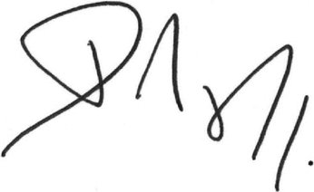
Deze handtekening verbindt eveneens de Vlaamse Gemeenschap, de Franse Gemeenschap, de Duitstalige Gemeenschap, het Vlaamse Gewest, het Waalse Gewest en het Brussels Hoofdstedelijk Gewest.
Cette signature engage également la Communauté française, la Communauté flamande, la Communauté germanophone, la Région wallonne, la Région flamande et la Région de Bruxelles-Capitale.
Diese Unterschrift bindet zugleich die Deutschsprachige Gemeinschaft, die Flämische Gemeinschaft, die Französische Gemeinschaft, die Wallonische Region, die Flämische Region und die Region Brüssel-Hauptstadt.
За Република България
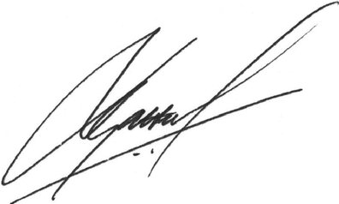
Za Českou republiku
For Kongeriget Danmark
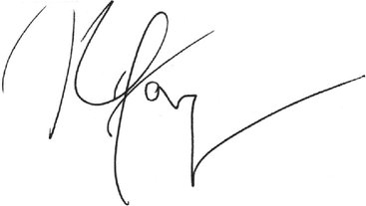
Für die Bundesrepublik Deutschland
Eesti Vabariigi nimel
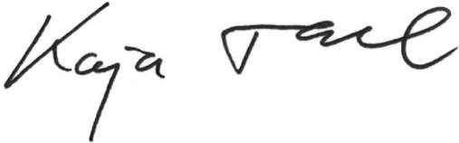
Thar cheann Na hÉireann
For Ireland
Για την Ελληνική Δημοκρατία
Por el Reino de España
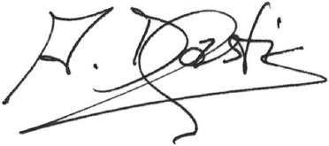
Pour la République française
Za Republiku Hrvatsku
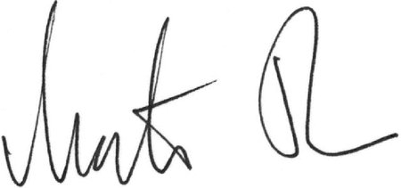
Per la Repubblica italiana
Για την Κυπριακή Δημοκρατία
Latvijas Republikas vārdā –
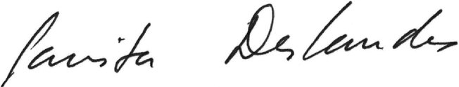
Lietuvos Respublikos vardu
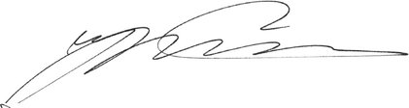
Pour le Grand-Duché de Luxembourg
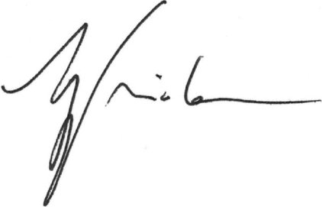
Magyarország részéről
Għar-Repubblika ta' Malta
Voor het Koninkrijk der Nederlanden
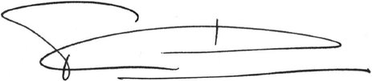
Für die Republik Österreich
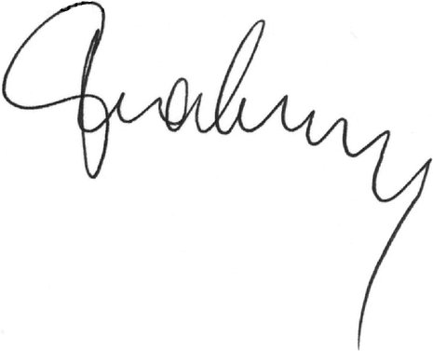
W imieniu Rzeczypospolitej Polskiej
Pela República Portuguesa
Pentru România
Za Republiko Slovenijo
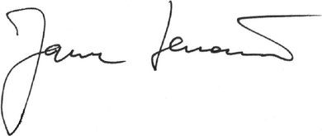
Za Slovenskú republiku
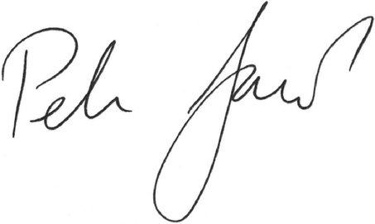
Suomen tasavallan puolesta
För Republiken Finland
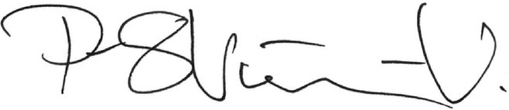
För Konungariket Sverige
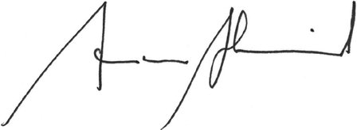
For the United Kingdom of Great Britain and Northern Ireland
За Европейския съюз
Por la Unión Europea
Za Evropskou unii
For Den Europæiske Union
Für die Europäische Union
Euroopa Liidu nimel
Για την Ευρωπαϊκή Ένωση
For the European Union
Pour l'Union européenne
Za Europsku uniju
Per l'Unione europea
Eiropas Savienības vārdā –
Europos Sąjungos vardu
Az Európai Unió részéről
Għall-Unjoni Ewropea
Voor de Europese Unie
W imieniu Unii Europejskiej
Pela União Europeia
Pentru Uniunea Europeană
Za Európsku úniu
Za Evropsko unijo
Euroopan unionin puolesta
För Europeiska unionen
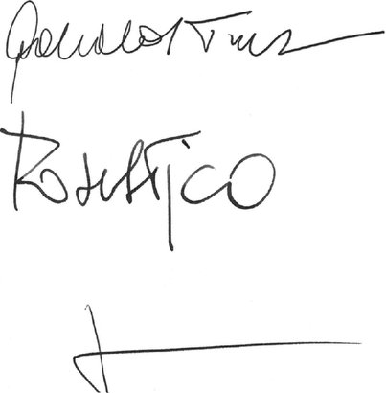
For Canada
Pour le Canada

